Resolution Counseling Center: Sending A Secure Message to Your Therapist
You can message your therapist anytime via the client portal. See below for step-by-step instructions:
- Go to https://resolutioncounseling.clientsecure.me/
- Choose “I’m an existing client”
- Our instant sign-in will ask for the email address we have on file (image 1)
- Enter that email and click “email me a link”
- Check that inbox for the email “Sign in to your client portal” and sign in
- Once in the portal, choose a profile if you have more than 1 and click the white conversation bubble at the top of the page to message your therapist (image 2)
- Your message will pop up on your therapist’s phone like a text message if they are signed into our system. They will get an email alerting them of your message if they are not.
- You will get an email when they reply with a quick link that lets you bypass the login process for 24 hours, enabling you to see and reply quickly to messages from your phone/device.
Image 1
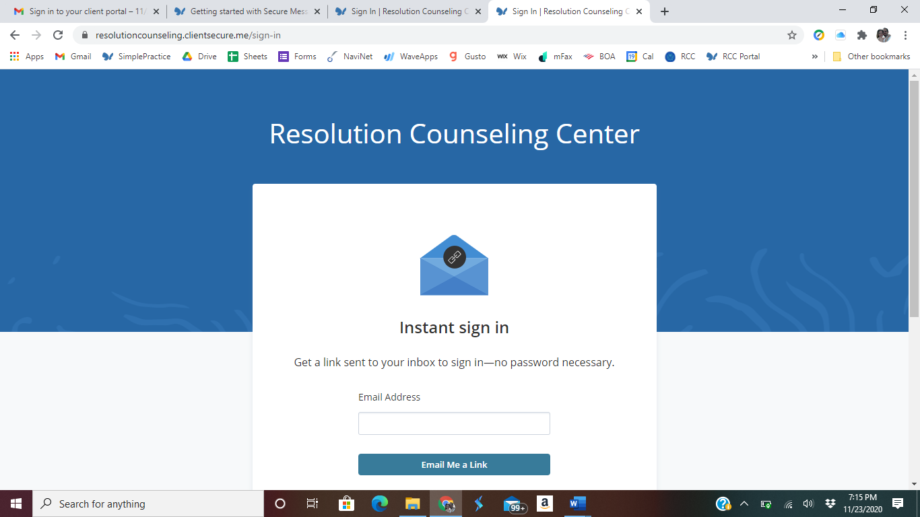
Image 2
